Cindy Cheng, Daoyang E, Yuwei Wu

QTM385-4 Final Project

11/21/2020

**2007-2008 Senators Bill Cosponsorship Network Analysis**

# 1. Introduction

In this paper we investigate ties of cosponsorship in the United States Senate. Bill sponsorship is an important part of the legislative process in the Senate. It provides a rich source of information about the social network between senators.

This study looks at legislative cosponsorship during the 110th Congress (2007-2008). Previous literature have mostly used data in the 1990s, but the current legislative dynamics might have undergone significant changes. Therefore, we intend to address this limitation by collecting more recent data and adding more attributes of senators.

In the following sections, we discuss past network studies of legislators and point out our contributions to the literature. We also outline the data and the methods we used to analyze the data. In our empirical analysis, we discuss the characteristics of the Senate network. Then, we use exponential random graph models (ERGMs) to provide detailed analysis of network formation mechanisms among senators.

# 2. Literature Review

## 2.1 Relationship between Communication and Cosponsorship

In Congress, sponsoring and cosponsoring legislation are generally understood to signify a senator’s support for the proposal. Since the mid-1930s in the Senate, legislators have had an opportunity to sign a piece of legislation as a cosponsor. A sponsor is a senator who introduces a bill in the Senate; other senators who show support for the bill by adding their names to this proposed legislation are its cosponsors. A bill can only have one sponsor, but there is no limit on the number of cosponsors per bill [(Oleszek, 2018)](https://www.zotero.org/google-docs/?dwnTki). It should be noted that if a member dies or resigns from the Senate, her/his name is still carried on the co-sponsorship rolls unless the member requests to remove the name.

Historically, seniority and reciprocity are the two most significant norms that operate in the Senate. Senior senators and members who take leadership positions have larger impact on the decision making process than junior members. Reciprocity means that legislators who cosponsor their colleagues' bill can expect similar support in return. (Harris, 1993). In the study of House and Senate cosponsorships, Fowler (2006) consistently finds that a legislator is more likely to cosponsor bills written by colleagues who sponsor his or her legislation. He suggests that reciprocity in cosponsorship is a way to strengthen relationships with other legislators.

Wilson and Young (1995) find that cosponsorship seems to have little impact on whether the bill eventually passes. Their study of the House and Senate of the 99th Congress indicate that although cosponsorship helped bills get initially passed in the legislative process, it helped little in terms of the final stage of decision making. Poole and Rosenthal (1985; 1991) have demonstrated that ideology is the most important determinant of voting decisions.

Since cosponsorship has limited influence on agenda setting, why senators still endorse it? What are senators trying to communicate with each other via cosponsorship? Previous studies on individual motivations have shown that in terms of potential political risk, sponsorship and cosponsorship cost little for senators to set agendas and show support for others. In addition, Kessler and Krehbiel’s (1996) study of the 103rd House of Representatives suggests that cosponsorship can be used for intralegislative signaling. In this vein cosponsorship is also regarded as an entrepreneurial action for senators to build reputations (Schiller, 1995).

Previous research has also shown that minority party members are more likely to cosponsor legislation than majority party members. According to the coalition theory, the bills from minority party members are less likely to get passed than bills from majority party members, so minority party members have greater incentive to solicit support from other senators.

## 2.2 Factors that Influence the Likelihood of Cosponsorship

Conventional wisdoms have shown the strong effect of seniority and party affiliation to the likelihood of cosponsorship, while other factors may also contribute to the likelihood that legislators will cosponsor one another’s legislation but with varying degrees.

The experience of a senator is an important predictor of cosponsorship. Martin (2015) shows that inexperienced senators are more likely to cosponsor legislation. Fowler (2006) also finds that more influential legislators are more likely to get their bills passed.

Burkett (1997) shows that expertise has a diminishing impact on cosponsorship due to a large staff size in Congress. Thus, we may expect to see little correlation between education level and cosponsorship.

The impact of race and gender is mixed among the previous findings. While Martin (2015) finds that race and gender have virtually no impact on senators’ decision to cosponsor, other studies suggest the opposite effects.

Bratton and Rouse (2011) demonstrate that homophily and transitivity affect the likelihood that a legislator cosponsors legislation within state legislatures. However, they point out that not all types of homophily significantly promote the frequency with which a legislator cosponsors a colleague’s bills. They find statistically significant effects for the same sex and or the same race variables only in two states.

Moreover, Fowler (2006) shows that legislators from the same state tend to sponsor more legislation and acquire more cosponsors.

## 2.3 Concepts and Definitions

Since we are interested in how closely connected senators are to other senators, we will first focus on measures of centrality. There are a number of effective ways to calculate centrality: Degree centrality measures the number of senators that one connects to. Closeness centrality means how close one senator is to all the other members. Betweenness centrality measures the number of shortest paths through one senator. Finally, eigenvector centrality shows the extent of connecting to important senators.

On the group level, we will look at cliques. A clique is defined as “a subset of actors in which every actor is adjacent to every other actor in the subset and it is impossible to add any more actors to the clique without violating this condition” (Borgatti, Everett and Johnson 2013). We will show the number and size of the groups among the 91 senators.

On the network level, we are interested in finding the density, centralization, transitivity, and homophily effects of the Senate network. Density refers to the proportion of pairs of senators who cosponsor bills to the number of ties possible. Centralization is associated with the extent to which cosponsorships are concentrated. Transitivity measures the tendency of a senator to collaborate with her/his collaborator’s collaborators. Homophily suggests senators who share similar characteristics are more likely to cosponsor than dissimilar senators.

## 2.4 Hypotheses

H1: Seniority is positively correlated with the number of bills cosponsored by a senator.

H2: There is a homophily effect among senators who share certain characteristics in party affiliation, gender, educational background, and state.

H3: Members of the minority party (Republican and Independent in 2008) will cosponsor more bills than members of the majority party (Democratic in 2008).

# 3. Research Design

## 3.1 Data

This study examines cosponsorship in the United States Senate. Our Senator network data is from Justin Grimmer's doctoral dissertation in political science at Harvard. It records instances of joint press releases issued by U.S. Senators. The ties are created among senators who co-attend a press conference because they have collaborated on sponsoring a bill. In addition, we collected the biographical information for 91 senators from a number of public sources such as Wikipedia and United States Senators. Their characteristics include: party, state, first year, seniority, age, race, gender, and education.

Party refers to political party affiliation. In this data set, there are only two senators who are not affiliated with the Democratic or Republican parties. Both of them are independent.

State refers to the state that the senator represents.

First year is a binary variable indicating whether the senator is the first year at the Senate.

Seniority refers to the tenure of the senator. It is measured by the number of years a senator has served in the Senate until 2008.

Age is a continuous variable indicating the age of a senator as of 2008.

Race is categorized into White and non-White groups. There are ten non-White senators in this session.

Gender is a binary variable of female and male.

Education level refers to the highest level of education a senator has obtained by 2008. We categorize the level of education into Bachelor’s degree, Master’s degree, and Doctoral or professional degree.

## 3.2 Methods

We first present a general cosponsorship network of the United States Senate to help give a general idea of the cosponsorship network. Then we provide relevant descriptive statistics regarding the prevalence of cosponsorship ties in the networks. To be specific, the descriptive statistics include Node Level Measures for the first 20 senators in our dataset with statistics such as degree, closeness, betweenness and eigenvector centrality, Group Level Measures with statistics such as clique size and corresponding number of cliques, and Network Level Measures with statistics such as density, centrality and transitivity.

Although previous studies also mostly implement ERGM models as major methods for measuring sponsorship and cosponsorship networks, we will still implement an ERGM model to analyze the cosponsorship network between the United States Senators. Our major strategy is using ERGMs (Wasserman & Pattison, 1996; Handcock et al., 2003; Robins et al., 2007a; Robins et al., 2007b; Robins et al., 2009). In an ERGM the probability of observing a network, w, is assumed to be

where W represents a random network, w the observed network, X the covariates, g(w, X) is a function of the covariates and selected endogenous network formation processes (e.g., mutuality, transitivity), θ a vector of coefficients measuring their effects, and C a normalizing constant which ensures the probability sums to 1. In plain terms, an ERGM assumes that the observed network is one realization of a family of networks which are generated by the effects of covariates and certain endogenous network formation processes. Prior research (Robins et al., 2001; Hunter et al., 2007) has shown that the above model is somewhat equivalent to an extended logit model

where the log odds of actor i sending a tie to j (i.e., = 1), conditioning on the covariates X and the rest of the network wr , is dependent on the change statistics (i.e., the changes in the covariates and selected network features when wij flips from 0 to 1) and their effects as measured by the vector θ. Thus, the estimated coefficients in ERGMs can be interpreted as log odds.

Specifically, in our main ERGM, we include covariate effects such as connection effects for covariates Age and Tenure, also homophily for Party, Gender, Race and Education. We also include the three network structural terms (i.e., the edgewise shared partner distribution (gwesp), the dyadwise shared partner distribution (gwdsp) and the in and out degree distribution (gwdegree)) besides an intercept-like term (i.e., edges) that accounts for the baseline connectivity of the network. Precedents for this type of model can be found, for example, in Equation (7) of Robins et al. (2001) and Table 8.2 of Lusher et al. (2013).

We fit the ERGMs using “statnet” in R (Handcock et al., 2003). We did not restrict the maximal number of cosponsorship ties each senator can make in the ERGMs. To facilitate model convergence, we fix the decay parameters for the structural terms at 0.1, as it has been shown that small decay parameters help to prevent degenerate ERGMs (Goodreau et al., 2008).

The associated P values test whether the coefficients from ERGM are statistically significant at the 5% level. For conciseness of presentation, we will focus on these P values in the analysis.

**4. Results**

## 4.1 Descriptive Results

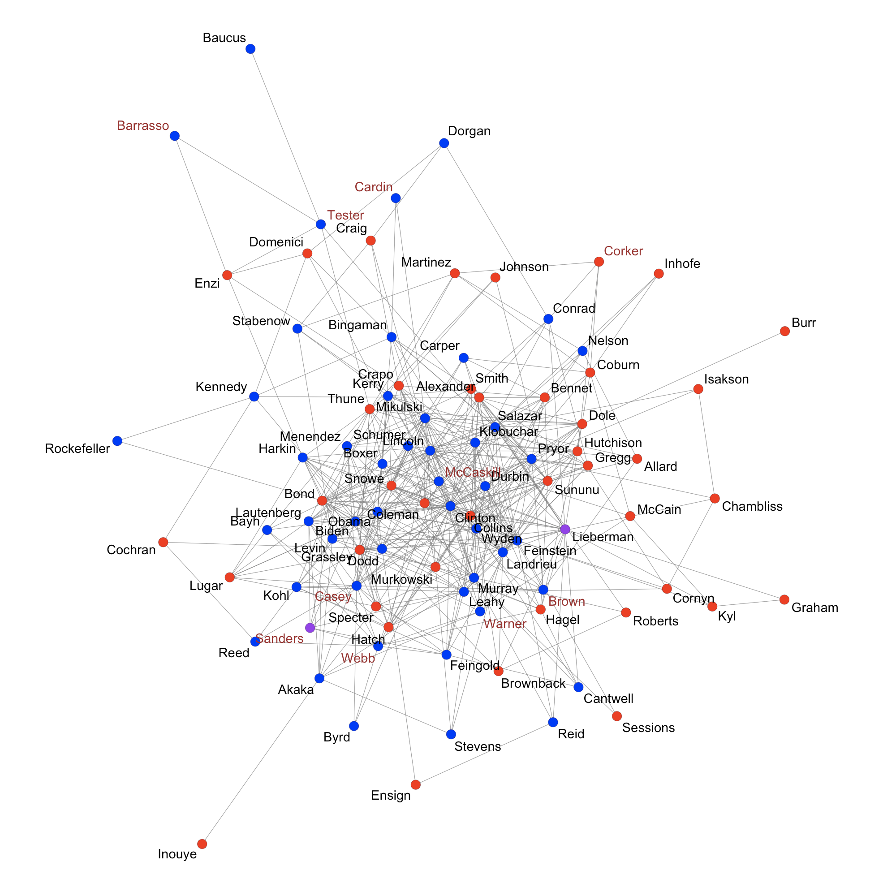

## Figure 1. 2008 Senators Cosponsorship Network of 91 Senators

We plot the undirected senate network of cosponsorship using R and color the attributes of party affiliation and whether 2008 is the first year senators served to represent the network in a more clear and vivid way. As shown in *Figure 1*, nodes of senators in the Democrat party are colored blue, nodes of senators in the Republican party red, and nodes of senators in the Independent party purple. In addition, names of senators that served their first year in the senate in 2008 are colored brown, whereas names of all other experienced senators remain in black.

Firstly, we can see that the number of senators in the Democrat and Republican party are almost even with the other two senators belonging to the Independent party. Although it seems that senators in the same party with the same color are positioned closely to each other in the network graph, we can still easily detect many ties that connect senators across parties in the graph. Secondly, there are roughly only 10 senators that are in their first year serving the senate. With 91 senators in this network, it is hard to find whether they have less cosponsorship ties than other senior senators directly, so we can later investigate the potential tie formation mechanism using our ERGM model. Apart from what is shown in the network plot, we find that females represent 16.48% of the senate and non-white people represent only 7.69% of all senators in this network. Besides, it is easy to tell that no senator is isolated in the network, meaning that they all have at least one cosponsorship tie with other senators in the senate by 2008, although some senators may have a very interwoven cosponsorship relationships while others only have one or two ties.

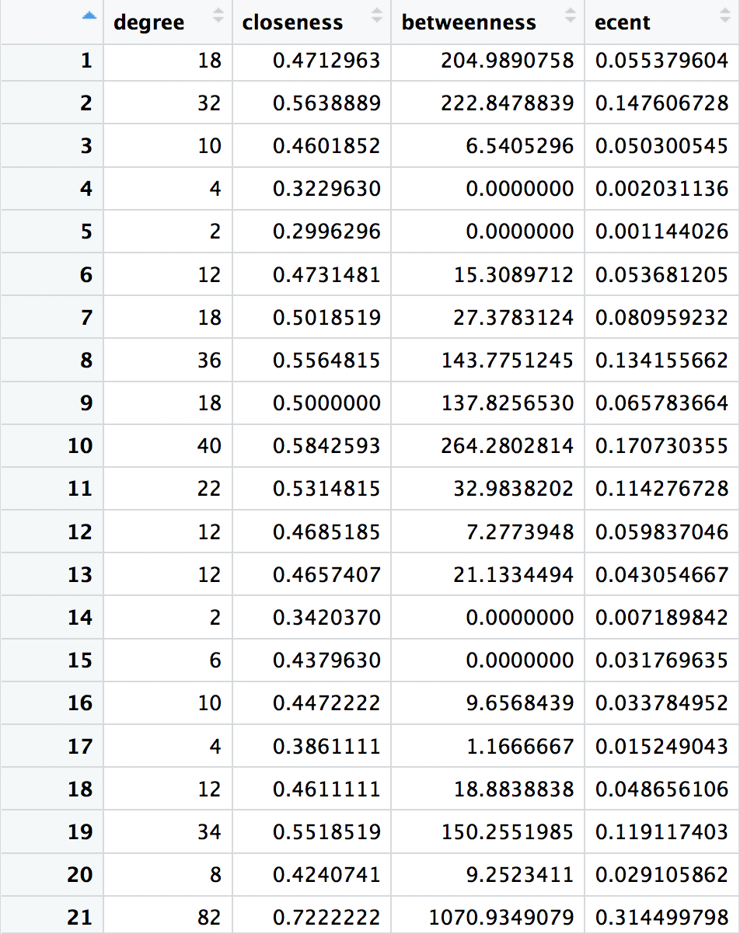

## Figure 2. The Node Level Measures of Randomly Selected 21 Senators

By focusing on each individual senate, we calculate each of their degree, closeness, and betweenness, and eigenvector centrality as presented in *Figure 2*. Based on our table of full results for all 91 senators, we find that node 21 which represents senator Clinton has a degree of 82, closeness score of 0.722, betweenness measure of 1070.9349, and a eigenvector centrality of 0.3145, all of which are the highest among all senators in 2008. Because this cosponsorship is an undirected network, each tie is counted twice when calculating the degree measure, so this means that senator Clinton has cosponsored 41 bills in total with other senators in the network by 2008. She is also the one that is closely related to all other senators because this node has the shortest path to all other vertices as indicated by the closeness measure. At the same time, she also serves the highest number of times as a bridge among different senators and connects together others in the network. Her high eigenvector centrality score also indicates that she connects to many other high-score vertices and should be the most important and influential senators in the cosponsorship network.

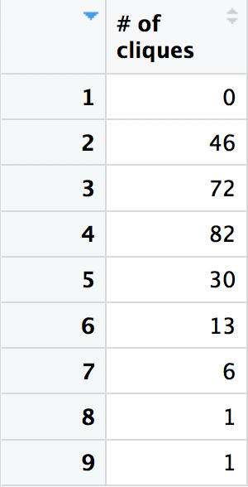

## Figure 3. Number and Size of Cliques Among All 91 Senators

Next we will analyze these 91 senators from group level, in particular, from the size of cliques and their according numbers. From the chart we see that, generally senators will tend to form cliques with size smaller than 5, such as size of 3 and 4, which have an according clique number of 72 and 82. There are also 46 cliques of size 2 and 30 cliques of size 5. But concerning clique size of 6, 7, 8 and 9, there are not many senators willing to stay in such a large clique. Also, all the senators tried to form cliques, there is no clique of size 1. Adding up the total number of cliques times clique size, we find out that the number is 923, which means that every senator on average is in more than 10 cliques.

So on group level, senators will tend to form cliques of size 2, 3 and 4, and senators on average will attend 10 cliques.

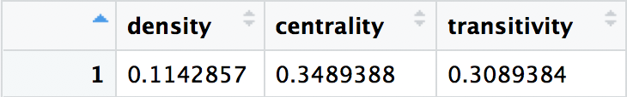

## Figure 4. Network Level Measures of the Cosponsorship Network

Lastly we will analyze these 91 senators from network level, by analyzing the cosponsorship network formed between the senators in 2008, we get the density, the centrality and transitivity of the network. The density of the network is 0.114287, which means that this network is a rather scattered network. The centrality of the network is 0.3489388, which means that this network is rather centered around several key nodes, this is also proved in our node level analysis, in which we notice that senator Cliton is one of the central nodes, who has cosponsored 41 bills in total to other senators. At last, the transitivity of this cosponsorship network is 0.3089, this particularly refers to the possibility of the cosponsorship relation of two senators is also connected to the third senator. We see that this network possesses a relatively large value of transitivity, and this is also proved in our group level analysis, which states that senators would like to form cliques of size 3 and 4.

So on network level, this cosponsorship network between senators in 2008 is a rather scattered network that centers on several key nodes and also enjoys a rather high amount of three-unit relations.

## 4.2 ERGM Results for Predicting the Senator Networks

To further investigate how different attributes of each senator and the homophily effects influence the formation of the cosponsorship network among all senators by 2008, we fit an ERGM on the collected network and attributes data. As shown below in *Figure 5*, the results suggest that the covariate effects of party affiliation, gender, and education are significantly affecting the formation of cosponsorship ties, and the homophily effects of age, tenure, and geography can also lead to an increase or decrease in senators’ cosponsoring behaviors.

In terms of the covariate effects of party affiliation, we find that senators in the Republican party are e^(-0.229) = 0.7953 times less likely to cosponsor a bill, whereas senators in the Independent party are e^(0.5259) = 1.692 times more likely to cosponsor a bill, as compared to those in the Democrat party. Gender can also affect the tie formation of this senate network, since males are e^(-0.7691) = 0.4634 times less likely to cosponsor bills than females in the senator. This difference is significant at 0.01 significance level, suggesting that even though there are much fewer females in the senate, they are very active in sponsoring bills than male senators. As for the highest educational level of senators, we find that obtaining a doctoral degree would significantly increase the number of bills one sponsors by e^(0.3016) = 1.352 times than those who only obtain a bachelor or a master degree, as the effect of these two lower levels of degrees are not so significantly different from each other. Age difference and tenure difference respectively will increase the number of cosponsorship bills assigned by two senators by a number of e^(-0.009279) = 0.99076 and e^(0.007487) = 1.00751 times, but both of these terms lack significance.

For the homophily effects in this network of senators, we find that people of the same age are only slightly more likely (e^(0.0143) = 1.0144 times) to cosponsor bills together than those of different ages, and senators of the same years of tenure are slightly less likely (e^(-0.0218) = 0.9784 times) to form a tie in sponsoring bill than those with different tenures. However, the homophily effects of geographical locations are very strong. Senators from the same states are e^(3.6051) = 36.7839 times more likely to cosponsor a bill than those from different states, conditioning on all other attributes.

Moreover, some local structures of the network, such as the degree statistics and transitivity, are also strongly affecting the formation mechanism of this cosponsorship network since all of these estimates are statistically significant at 0.01 significance level. Firstly, having one more cosponsored bill would increase the likelihood of forming another tie by e^(2.6315) = 13.895 times. Secondly, the transitivity mechanism is also very important in this network. Two senators who have cosponsored a bill are e^(0.8938) = 2.44 times more likely to close the triangle if one of them also cosponsor a bill with another senator. However, if two senators have not cosponsored a bill before, they are 3^(-0.1466) = 0.8638 times less likely to cosponsor bills with someone who has cosponsored a bill with the other senator.

In *Figure 6*, the goodness-of-fit diagnostics shows how well our ERGM model is performing on predicting the formation of the cosponsorship network among senators in 2008. We think that the ERGM model is performing well in modeling the proportions of nodes in the network as the degree increases with only a few exceptions. The simulations fail to capture the proportions of nodes when the degree is equal to 5, 7-8, 27-28, and 41 in the observed network. In terms of the proportions of edges shared among partners, this fitted model may overestimate the proportions when the number of edgewise shared partners is smaller and underestimate the proportions when the number is larger in the observed network. Besides these simulations, we think the model precisely captures the proportions of dyads as the minimum geodesic distance increases, since the observed parameters are within the 95% confidence interval of the ERGM simulations. Therefore, we believe that this selected ERGM model is producing satisfying predictions for the formation of the observed coponshorship network among senators in 2008.

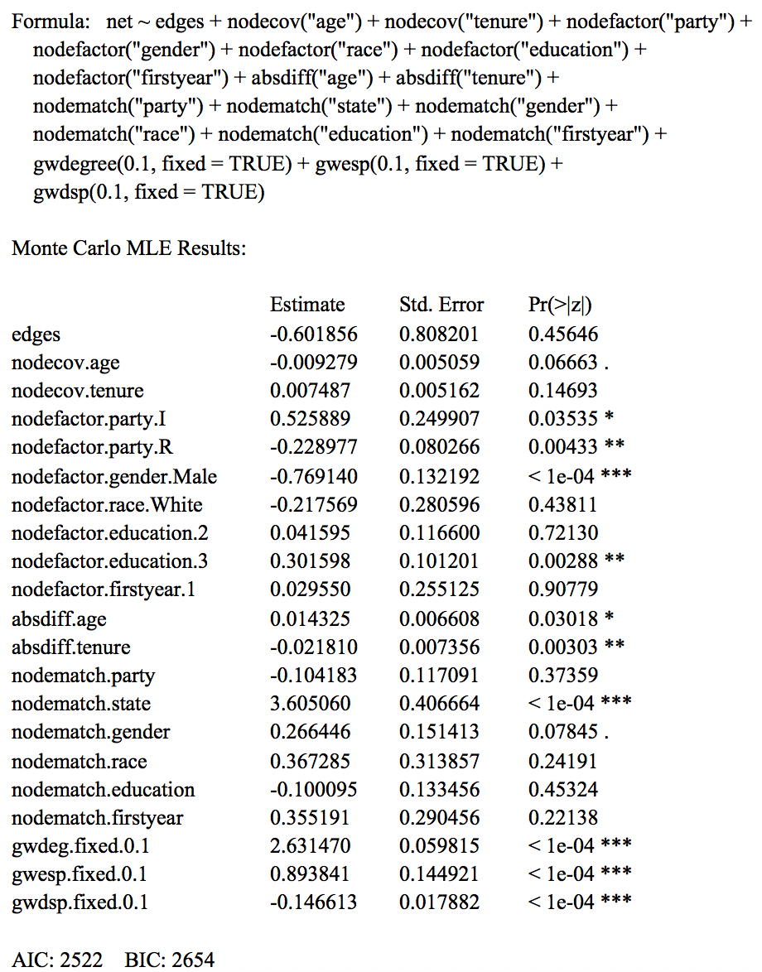

Figure 5. ERGM Results of Cosponsorship Network

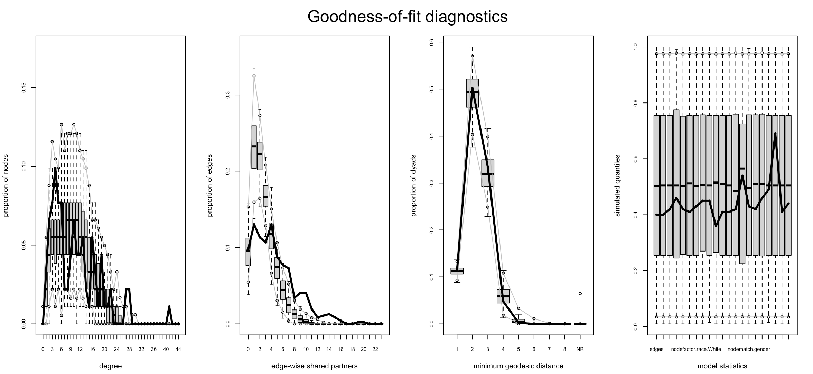

## Figure 6. Goodness-of-fit Diagnostics of the Fitted ERGM

# 5. Conclusion and Discussion

In this study, we proposed covariate effects, homophily and local structures as for having influential effects on forming the cosponsorship network between the U.S. senators in 2008 and use datasets that collected from Justin Grimmer's doctoral dissertation in political science at Harvard as well as the biographical information for 91 senators from a number of public sources such as Wikipedia and United States Senators. We find that, covariate effects of party affiliation, gender, and education, homophily effects of age, tenure, and geography and local structures of the network, such as the degree statistics and transitivity are significantly affecting the formation of cosponsorship ties.

On the one hand, concerning the hypothesis, we do find strong supporting statements for our hypothesis 2, that there is a homophily effect among senators who share certain characteristics in party affiliation, gender, educational background, and state. However, on the other hand, concerning the left two hypotheses, the results found are not that satisfactory. First let’s talk about our first hypothesis, which states that seniority is positively correlated with the number of bills cosponsored by a senator. Although we make this hypothesis out of conventional wisdom in related readings, we fail to specify the definition of seniority, so we choose to consider both tenure and age. The covariate effects of tenure do support our hypothesis but it lacks significance, while the covariate effects of age negate our null hypothesis, which makes our first hypothesis questionable. Our third hypothesis, which states that members of the minority party (Republican and Independent in 2008) will cosponsor more bills than members of the majority party (Democratic in 2008), is also rejected by our statistics which show that Democrats actually cosponsor more bills than Republicans.

Several limitations in our data or analysis are worth pointing out. First, we only run ERGM on one set of cosponsorship network data, which could lead to the problem of lacking generality. Future research could incorporate more sets of senator cosponsorship data to verify our results. Second, since our data is mainly second handed, we are unable to determine the accuracy of these data. Future researchers might improve on this weakness through getting first handed data if possible.

In sum, finding influential factors for building senator cosponsorship networks is an exciting research project with many potential applications, opportunities, and challenges.

# 

# Appendix

*A.1 R CODE*

# Import packages

library(statnet)

# Import and clean up datasets

senate <- read.csv("Senate.csv", header = T)

att <- read.csv("att.csv", header = T)

att["Gender"] <- as.character(ifelse(att["Gender"]=="M","Male","Female"))

att["Race"] <- as.character(ifelse(att["Race"]=="W","White","Non-White"))

# Create a network for senators and set attributes

net <- network(senate, directed = F)

set.vertex.attribute(net, "party", att$Party)

set.vertex.attribute(net, "state", att$State)

set.vertex.attribute(net, "firstyear", att$FirstYear)

set.vertex.attribute(net, "tenure", att$Tenure)

set.vertex.attribute(net, "age", att$Age)

set.vertex.attribute(net, "race", att$Race)

set.vertex.attribute(net, "gender", att$Gender)

set.vertex.attribute(net, "education", att$Education)

# Plot the network

png("Senate.png", width = 2000, height = 2000, res=35)

plot.network(net, displaylabels = T, boxed.labels = FALSE, vertex.cex = 0.6, label.cex = 5,

vertex.col = ifelse(att$Party=="I", "purple", ifelse(att$Party=="D", "blue", "red")),

label.col = ifelse(att$FirstYear=="1", "brown", "black"), edge.lwd = 0.3, edge.col = "gray50")

dev.off()

# Node level measures

degree <- degree(net)

closeness <- closeness(net, cmode="suminvdir")

betweenness <- betweenness(net)

ecent <- evcent(net)

table1 <- cbind(degree, closeness, betweenness, ecent)

# Group level measures

clique <- clique.census(net)

table2 <- as.matrix(clique$clique.count[,1])

colnames(table2) <- c("# of cliques")

# Network level measures

density <- gden(net)

centrality <- centralization(net, degree)

transitivity <- gtrans(net)

table3 <- cbind(density, centrality, transitivity)

# ERGM

model <- ergm(net ~ edges + nodecov("age")+ nodecov("tenure")+ nodefactor("party") +

nodefactor("gender")+ nodefactor("race") + nodefactor("education") + nodefactor("firstyear") +

absdiff("age") + absdiff("tenure") + nodematch("party")+ nodematch("state") + nodematch("gender")+

nodematch("race")+ nodematch("education")+ nodematch("firstyear")+

gwdegree(0.1, fixed = TRUE)+ gwesp(0.1, fixed = TRUE) + gwdsp(0.1, fixed = TRUE),

control = control.ergm(MCMLE.maxit = 300, MCMC.burnin=10000, MCMC.interval=200, seed = 123 ))

summary(model)

est <- as.matrix(summary(model)$coefs)[,c(1,2,4)]

gof <- gof(model)

par(mfrow=c(1,4))

plot(gof)

# References

Bratton, Kathleen A., and Stella M. Rouse. 2011. “Networks in the Legislative Arena: How Group Dynamics Affect Cosponsorship.” Legislative Studies Quarterly 36(3):423–60. doi: <https://doi.org/10.1111/j.1939-9162.2011.00021.x>.

Burkett, Tracy. 1997. Cosponsorship in the United States Senate: A network analysis of Senate communication and leadership, 1973–1990. Ph.D. dissertation. Columbia, SC: Sociology, University of South Carolina.

Fowler, James H. 2006. “Connecting the Congress: A Study of Cosponsorship Networks.” Political Analysis 14(4):456–87. doi: 10.1093/pan/mpl002.

Goodreau, S. M., Handcock, M. S., Hunter, D. R., Butts, C. T., & Morris, M. (2008). A statnet tutorial. *Journal of Statistical Software*, **24**(9), 1.

Handcock, M. S., Hunter, D. R., Butts, C. T., Goodreau, S. M., & Morris M. (2003). statnet: Software tools for the statistical modeling of network data. URL <http://statnetproject.org>.

Hunter, D. R. (2007). Curved exponential family models for social networks. *Social Networks*, **29**(2), 216–230.

Kessler, Daniel, and Keith Krehbiel. 1996. “Dynamics of Cosponsorship.” The American Political Science Review 90(3):555–66. doi: 10.2307/2082608.

Lusher, D., Koskinen, J., & Robins, G. (2013). *Exponential random graph models for social networks: Theory, methods, and applications*. New York: Cambridge University Press.

Martin, Steven A. 2015. “Social Capital at the Capitol: A Social Network Analysis of Interest Group Influence in the 111th Congress.” Ph.D., University of Kentucky, United States -- Kentucky.

Oleszek, Mark J. 2018. “Sponsorship and Cosponsorship of Senate Bills.” 5.

Poole, Keith T., and Howard Rosenthal. 1997. Congress: A Political-Economic History of Roll Call Voting. New York: Oxford University Press.

Robins, G. L., Elliott, P., & Pattison, P. (2001). Network models for social selection processes. *Social Networks*, **23**(1), 1–30.

Robins, G., Pattison, P., Kalish, Y., & Lusher, D. (2007a). An introduction to exponential random graph (p∗) models for social networks. *Social Networks*, **29**(2), 173–191.

Robins, G., Snijders, T., Wang, P., Handcock, M., & Pattison, P. (2007b). Recent developments in exponential random graph (p∗) models for social networks. *Social Networks*, **29**(2), 192–215.

Robins, G., Pattison, P., & Wang, P. (2009). Closure, connectivity and degrees: New specifications for exponential random graph (p∗) models for directed social networks. *Social Networks*, **31**(2), 105–117.

Schiller, Wendy J. 1995. “Senators as Political Entrepreneurs: Using Bill Sponsorship to Shape Legislative Agendas.” American Journal of Political Science 39(1):186–203. doi: 10.2307/2111763.

Wasserman, S., & Faust, K. (1994). *Social network analysis: Methods and applications*. Cambridge: Cambridge University Press.

Wasserman, S., & Pattison, P. E. (1996). Logit models and logistic regressions for social networks: I. An introduction to Markov graphs and p∗. *Psychometrika*, **61**(3), 401–425.

Wilson, Rick K., and Cheryl D. Young. 1997. “Cosponsorship in the U. S. Congress.” Legislative Studies Quarterly 22(1):25–43. doi: 10.2307/440289.